Lab assignment 2

Subject: Object Oriented Programming

Class: BS-CYS 2A

Name: Talha Ahmed

Roll no: CYS-241014

ALL OF THE PROGRAMS ARE INCCLUDED IN THE RESPECTED FOLDERS “CHANGE PACKAGE TO RUN IT” also I have included screenshot of the working if the programs for some reason is not working as intended.

Q1) STARTS HERE

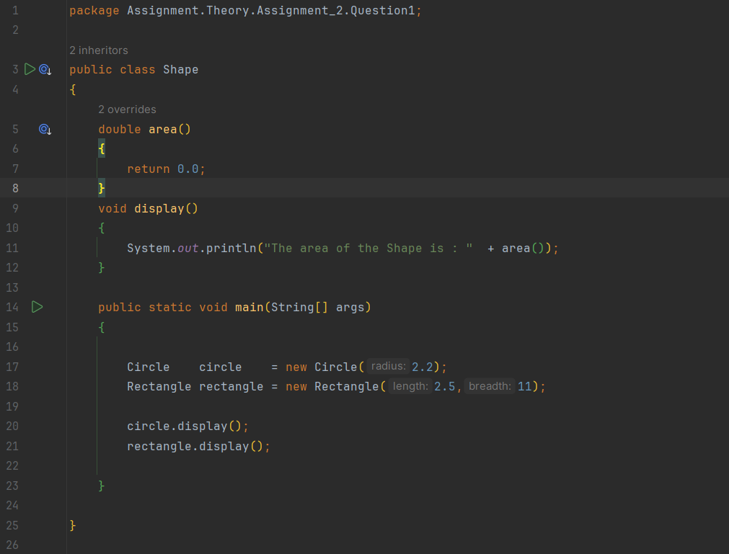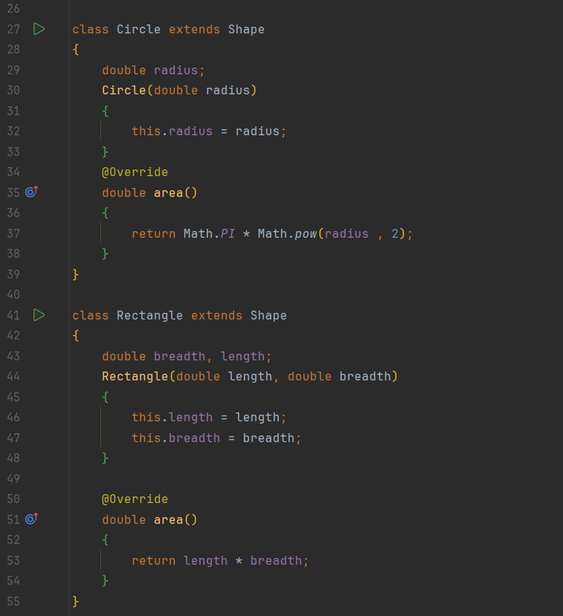

Output:

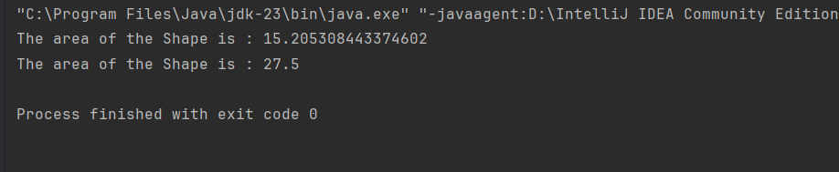

Q2) STARTS HERE

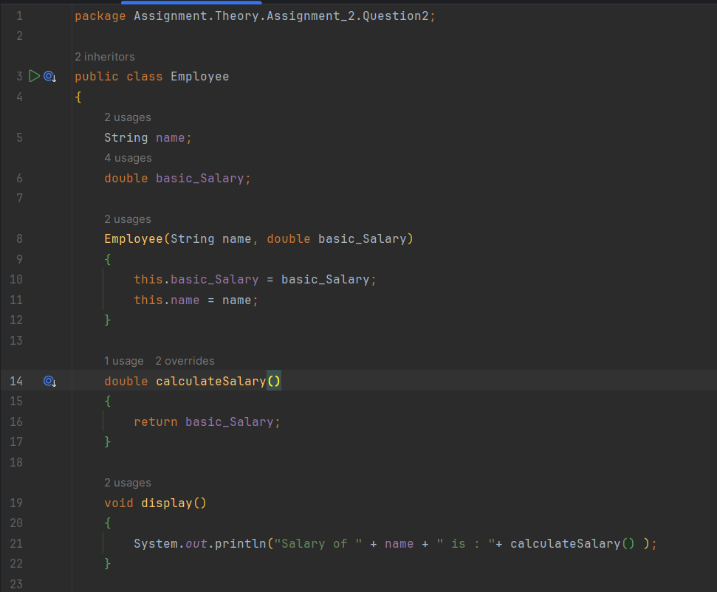

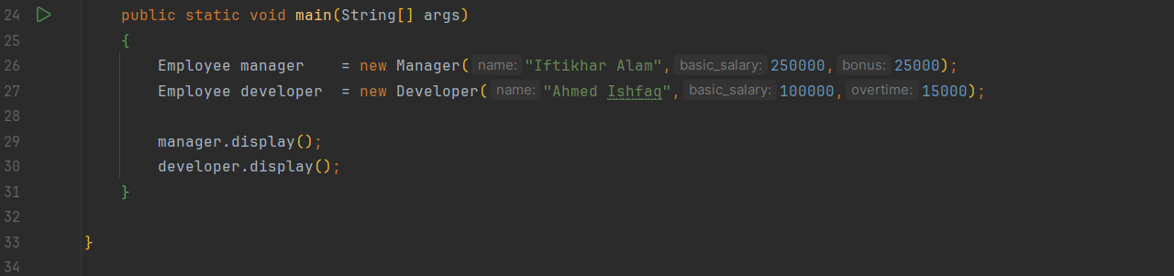

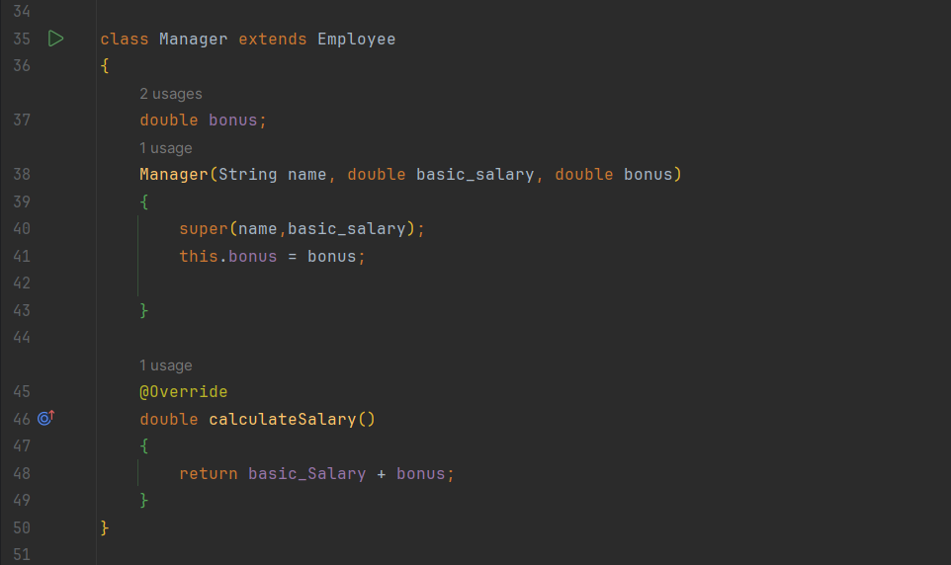

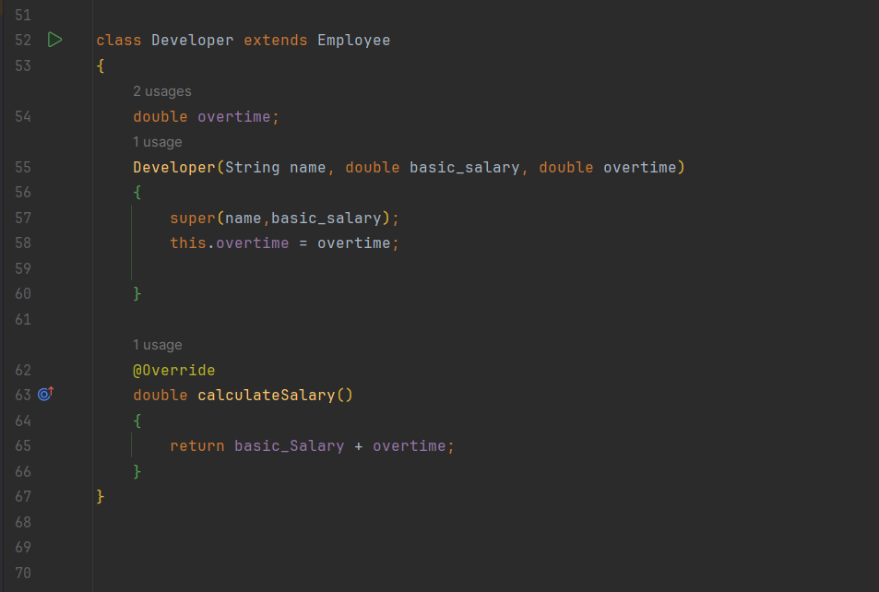Output:

